*Florida International University*

*School of Computing and Information Sciences*

Software Engineering Focus

Feature Document

User Story ID <670 Log in Persistence>

**Name: Bertha M Perez**

**Team Member(s): Bertha M Perez**

**Frank Hernandez**

**Project: Snackability 1.0**

**Product Owner(s)**: Dr. Cristina Palacios

**Mentor(s)**: Dr. Cristina Palacios

**Instructor**: Masoud Sadjadi

**User Story Name:** 670 Log in Persistence

### **Description:**

* As a User I would like to authenticate on the mobile app just once so the application should save my credentials.

### **Acceptance Criteria:**

1. Be able to open the app without having to sign in

### **Related Tasks:**

**Use Case**

|  |  |
| --- | --- |
| Use Case Name: Login Persistence | |
| Participant Actor: Unregistered user & FirebaseUI | |
| Entry Condition:   * User already signed in | |
| Exit Condition: User log in automatically without input credentials | |
| **Flow of Events** | |
| **Actor Steps** | **System Steps** |
| 1.Open Snackability app | 2.Send credentials (saved key)  3.FirebaseUI accept key  4.Show user interface |
|
| **Use Case Exceptions** | |
| **Actor Steps** |  |
|  |  |

**Use Case Diagram <**you can use draw.io**>**

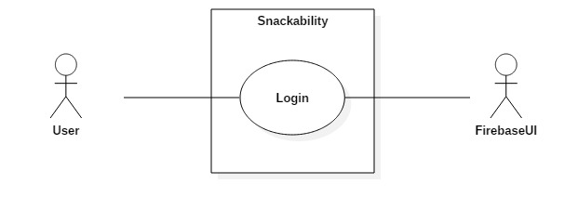

**Sequence Diagram**

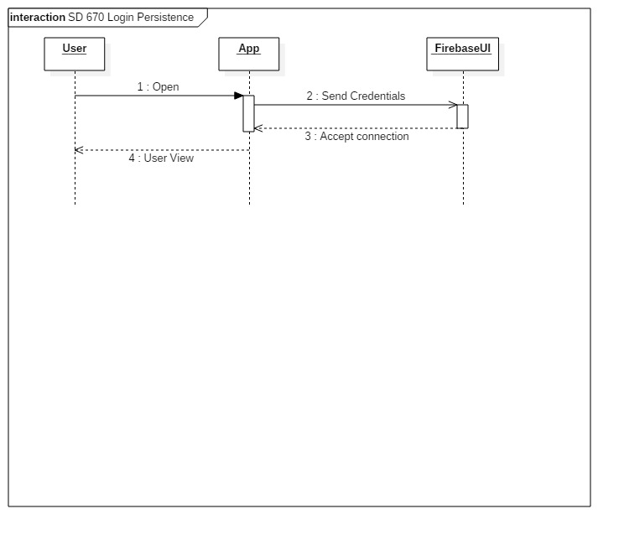

**Class Diagram**

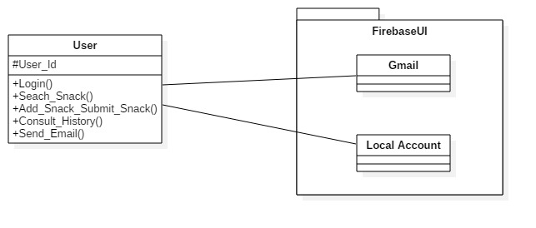

**Note:**

FirebaseUI is an open-source library that offers simple, customizable UI bindings on top of the core [Firebase](https://firebase.google.com/) SDKs. It aims to eliminate boilerplate code and promote best practices (both user experience and security) for authentication.

“Easily add sign-in to your Android app with FirebaseUI | Firebase.” *Google*, Google, firebase.google.com/docs/auth/android/firebaseui.

**Unit Test**

* Test case ID: user_login_persistence_ID
* Description/Summary of Test: Given the fact that the user already sign up, when the user open the app, then the server should return the search page
* Pre-condition: User must be registered
* Expected Results: Server should return the search page
* Actual Result: Search page returned
* Status (Fail/Pass): Pass

**Integration Test**

**Visual User Guide** <like one or two screenshots of the feature. For the hardware project, a photo of device is required>